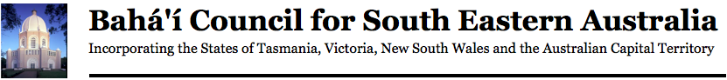
Sydney Bahá’í Centre, 107 Derby Street Silverwater, NSW 2128 – Tel: (02) 9748 1297 • Email: secretariat@sea.bahai.org.au

Approved Provider Complaint Form

If you have a complaint about any aspect of our school services we are keen to hear from you.
Please complete this form in English and send it to your approved provider.
General Information

Please select from the following. I am a/an:
󠄀 parent 󠄀󠄀 student 󠄀󠄀 member of the public 󠄀󠄀 employee

2. Personal details
Title |  |  | Mr |  | Mrs |  |  | Ms |  |  |  | Miss |  |  |  |  |  |  | Other
What is your family name?
What is your given name?
3. Contact details
What is your current residential address?
 |  |  |  |  |  |  |  |  |  |  |  |  | Postcode
What is your mailing address? (if different to residential address)
 |  |  |  |  |  |  |  |  |  |  |  |  | Postcode
Email address
Telephone number
Mobile phone number
Preferred contact method: |  |  | Phone |  |  | Mobile |  |  |  | Letter |  |  |  |  |  |  | Email
4. Complaint details
Have you lodged a complaint about this issue before? |  |  | Yes |  |  |  |  |  | No
 |  |  | If yes, when:
5. Complaint summary
When it happened
Where it happened
Who was involved
What happened (details of your complaint)

What you would like to happen to resolve your complaint

Attach any documentation that supports your complaint
6. Acknowledgement
All the information provided above is true and correct to the best of my knowledge.
Signature |  |  |  |  |  |  |  |  |  |  | Date
7. Privacy notice
We will only use the information collected on this form to resolve your complaint and access will only be provided to authorised officers.
8. Office use only
Action officer
Position |  |  |  |  |  |  |  |  |  |  |  |  |  | Date
Complaint lodged |  |  |  | by telephone |  |  | in person |  |  |  |  |  |  |  |  | in writing
Notes

